Annex-A

BALOCHISTAN UNIVERSITY OF ENGINEERING AND TECHNOLOGY KHUZDAR



Audit Procedure

FOR ISO CERTIFICATION

ISO 19001-2015

INTERNAL AUDIT PLAN

Table of Contents
1.0 GENERAL INFORMATION 1
1.1 Purpose 1
2.0 Audit Scope 1
3.0 Audit Objectives 1
4.0 Audit Criteria 2
5.0 Audit Procedure 2
6.0 Audit Method (7.4 & Table A.1 of Annex-A of ISO 19011-2018) 3
7.0 Process flow of the Audit 4
8.0 Roles and Responsibilities 5

GENERAL INFORMATION

1.1 Purpose

The purpose of the Internal Audit Plan is to initiate Internal Audit (First party Audit) of Balochistan University of Engineering and Technology, Khuzdar to assess the conformity and Quality Management System of the institution for external Audit (third party Audit) under ISO 19011-2018 leading to ISO certification in its standard # 19001-2015.

2.0 Audit Scope

The extent and boundaries of an audit generally includes a description of the physical and virtual-locations, functions, organizational units, activities and processes, as well as suppliers. A virtual location is where an organization performs work or provides a service using an on-line environment allowing individuals irrespective of physical locations to execute processes

3.0 Audit Objectives

The audit objectives are to conduct thorough and impartial audit of all official procedures, office business, working culture in vogue in all sections, departments, offices of Balochistan University of Engineering and Technology, Khuzdar and assess that:-

    - They are functioning strictly as per laid down rules and regulations.
    - They are meting minimum international standards defined in ISO 9001-2015.
    - The Degree being issued to the passing out graduates, fulfills the purpose provides maximum job opportunities and market demands.
    - The courses being taught to the students are designed as per current market demand.
    - The suggestions for improvement are welcomed by the decision makers.
    - The admissions and inductions are made strictly in accordance with the rules and regulations in order to merit without discrimination and transparency is maintained in all such processes.
    - The Procurement of university goods and other articles are made as per prescribed rules.
    - The financial and other resources of the university are utilized rightly.
    - The smart working culture is followed with more output against less time and resources.
    - Job descriptions or of all employees are devised and displayed to the employees without language barriers.
    - The rules, regulations and other procedures pertaining to university affairs are easily accessible and properly displayed to all students and employees.
    - The guidelines of regulatory bodies are followed in later and spirit.
    - Determination of the extent of conformity of the management system of BUET, Khuzdar, or its sub campuses, with audit criteria;
    - Evaluation of the capability of the management system to assist the organization in meeting relevant statutory and regulatory requirements and other requirements to which the organization is committed;
    - Evaluation of the effectiveness of the management system in meeting its intended results;
    - Identification of opportunities for potential improvement of the management system;
    - Identification of risk factors and likely barriers which are not letting the university for further progression.
    - Evaluation of the suitability and adequacy of the management system with respect to the context and strategic direction of the auditee;
    - Evaluation of the capability of the management system to establish and achieve objectives and effectively address risks and opportunities, in a changing context, including the implementation of the related actions

4.0 Audit Criteria

The audit criteria may include one or more of the following: applicable policies, processes, procedures, performance criteria including objectives, statutory and regulatory requirements, management system requirements, information regarding the context and the risks and opportunities as determined by the auditee (including relevant external/internal interested parties requirements), sector codes of conduct or other planned arrangements

5.0 Audit Procedure

The Lead Auditor (Audit Team Leader) accompanied by Audit team will conduct step by step financial, performance and operational audits of all Sections Department of Balochistan University of Engineering and Technology, Khuzdar as per following procedure:-

- To check Audit control procedure
- To check record control procedure
- To check and control Non conformities
- To explore and highlight Non conformities.
- Suggest improvements and initiate corrective actions
- Arrangement of Management Review Meeting (MRM) and discuss all non-conformities and seek corrective actions.
- Follow up of audit findings.

6.0 Audit Method (7.4 & Table A.1 of Annex-A of ISO 19011-2018)

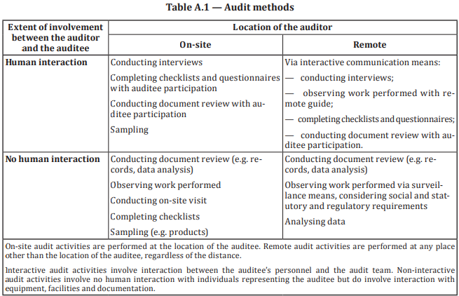

7.0 Process flow of the Audit
The process flow of Internal Audit is as follows:-

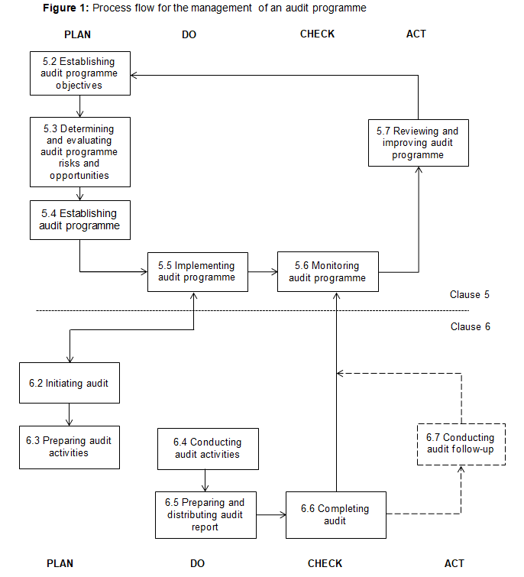

8.0 Roles and Responsibilities

It will be the responsibility of all Sectional and Departmental Heads of Balochistan University of Engineering and Technology, Khuzdar to extend maximum possible cooperation with the Internal Audit Team. In case of failure to cooperate, the Audit team will be worthy to submit Non conformity report against his section/department.

